Pollution Incident Response
Management Plan – (PIRMP)

Cleanaway Operations Pty Ltd
Riverstone

Princes Street
Riverstone, NSW 2765

EPA LICENCE NO. 13102

Revision Status:

Date | Issue | By | Checked | Approved and understood by
12/09/2023 | 1 | NA/HR | MB | MB
08/08/2024 | 2 | MH | MB | MB
07/08/2025 | 3 | MB | MB | MB
06/08/2026 | 4 | ZP/RG | SM | SM

Figure 1 outlines the Cleanaway protocol for the response to pollution incidents
If the environmental incident does not cause or threaten to cause environmental harm

Call Site Manager
If the environmental incident causes or threatens to cause environmental harm

Implement PIRMP

Incident is managed by the
Responsible Person/s (refer to Section 2). This is the Site Manager or their Deputy.

Responsible person to delegate the following actions:
- Visually assess the situation.
- Evacuate the site (or part of site) if there is an immediate threat to human health.
- Commence protocol for the notification of pollution incidents (see Figure 2, Line A).
- Take action/s to minimise environmental impact if safe to do so (refer to Section 6).
- Isolate source of spill, noise, odour etc if safe to do so.
- Commence clean-up if source can be isolated and it is safe to do so.

Site Manger to delegate the following actions:
- Visually assess the situation.
- Evacuate the site (or part of site) if there is an immediate threat to human health.
- Commence protocol for the notification of pollution incidents (see Figure 2, Line B).
- Take action/s to minimise environmental impact if safe to do so (refer to Section 6).
- Isolate source of spill, noise, odour etc if safe to do so.
- Commence clean-up if source can be isolated and it is safe to do so.

- When emergency services arrive on site, they become site controller.
- Site Manager to update regulatory authorities on incident and actions taken by site personnel.
- Site Manager to implement actions as directed by regulatory authorities.

Other actions during and post incident*
- Log incident into Myosh;
- If reported by community member enter into Myosh as a complaint; and
- If required seek assistance from specialist consultants/contractors.

*May be assisted by EBP or PEBP

Other actions during and post incident*
- Log incident into Myosh;
- If reported by community member enter into Myosh as a complaint;
- If required seek assistance from specialist consultants/contractors; and
- Further updates and an incident close-out report will be required by EPA.

*May be assisted by EBP or SEBP

Figure 2 outlines the Cleanaway protocol for the notification of pollution incidents

A. If the incident presents immediate threat to human health, environment or property

Call 000
B.
Contact Regional Manager, General Manager and Principal Environmental Business Partner

Branch Manager to consult with Regional Manager and Principal Environmental Business Partner to determine if incident is notifiable.
Contact Regional Manager, General Manager and Principal Environmental Business Partner.

Notify the relevant authorities*
In the following order using their 24-hr hotlines (refer to Section 3):
- EPA;
- Comcare;
- Blacktown Council; and
- NSW Ministry of Health.

Provide the following:
- Their name and contact details;
- Location of the pollution incident/emergency;
- Nature of the pollution incident/emergency; and
- Details of any assistance required.

*May be assisted by EBP or PEBP

If notifiable, Site Manager or Regional Manager will:

Line A
Line B

Notify the relevant authorities*
In the following order using their 24-hr hotlines (refer to Section 3):
- Fire & Rescue without immediate threat;
- EPA;
- Comcare;
- Blacktown Council; and
- NSW Ministry of Health.
Provide the following:
- Their name and contact details;
- Location of the pollution incident/emergency;
- Nature of the pollution incident/emergency; and
- Details of any assistance required.

*May be assisted by EBP or PEBP

If pollution incident is causing or threatens to cause harm to human health outside of premises:
- Contact neighbours by phone - refer to Section 4 for names and contact numbers of neighbours.
- If unable to contact by phone, then physically visit business address (assisted by Emergency Services, where required).

If pollution incident continues then further notification may need to occur (refer to Section 9) including:
- Mailbox drops;
- Warning signs;
- Media release; and
- Cleanaway webpage updates.

POLLUTION INCIDENT RESPONSE MANAGEMENT PLAN (PIRMP) – Scanline - Riverstone
Approved by: |  | Sarah McMurtry
Position/Title: | Branch Manager |  | Date: | 06/08/2026
PURPOSE:

Cleanaway Operations Pty Ltd (Cleanaway) holds an Environment Protection Licence (EPL) with the NSW Environment Protection Authority (EPA) for the Riverstone - Princes St site. As per the Protection of the Environment Operations Act 1997 (the POEO Act), the holder of an Environment Protection Licence must prepare, keep, test and implement a pollution incident response management plan (PIRMP) that complies with Part 5.7A of the POEO Act in relation to the activity to which the licence relates.

If a pollution incident occurs in the course of an activity so that material harm to the environment (within the meaning of section 147 of the POEO Act) is caused or threatened, the person carrying on the activity must immediately implement this plan in relation to the activity required by Part 5.7A of the POEO Act.

A written copy of this plan must be kept at the Riverstone - Princes St site or where the activity takes place in the case of mobile plant licences and be made available on request by an authorised NSW EPA Officer and to any person who is responsible for implementing this plan.

- Location of PIRMP (hardcopy) onsite: Safety Notice Board in lunch room, and Environment Folder in Operations Manager’s office.
- Location of PIRMP (softcopy): Site Files & Cleanaway Portal.

Parts of the plan must also be available either on a publicly accessible website, or if there is no such website, by providing a copy of the plan to any person who makes a written request. The sections of the plan that are required to be publicly available are set out in clause 98D of the Protection of the Environment Operations (General) Regulation 2022.

- Location of PIRMP (website copy): https://www.cleanaway.com.au/about-us/our-business/environmental-management/

NOTE: This plan must be developed in accordance with the Protection of the Environment Operations Act 1997 and the Protection of the Environment Operations (General) Regulation 2022.

Licensees should also refer to the NSW EPA’s Guideline: Pollution incident response management plans.
RELATIONSHIP WITH OTHER DOCUMENTS:

This Plan should be read in conjunction with the following documents:
- Riverstone - Princes St Site Emergency Management Plan (HSE PL 2.1.3.01.01)
- Riverstone - Princes St Environmental Risk Register

These documents are located at https://cleanaway.sharepoint.com/sites/portal/pages/LandingPage.aspx

- Environment Protection Licence (EPL) Details
Name of licensee:  (including ABN) | Cleanaway Operations Pty Limited  40 010 745 383
EPL number: | 13102
Premises name and address: | Cleanaway Liquids & Technical Services (LTS)  55 Princes St  Riverstone NSW 2765
Company or business contact details: | Name: Sarah McMurtry  Position or title: Branch Manager  Contact number/s: (02) 9421 7400 or 0498 972 002  Email: Sarah.McMurtry@cleanaway.com.au
Website address: | www.cleanaway.com.au
Community Hotline: | 1800 213 753
Emergency Spills Hotline: | 1800 SPILLS (1800 774 557) or 000
Scheduled activity on EPL: | Waste Processing (non-thermal treatment);  Waste Storage.
Fee based activity on EPL: | Non-thermal treatment of hazardous and other waste;  Waste Storage – hazardous, restricted solid, liquid, clinical and related waste and asbestos waste.
- Pollution incident – Person/s responsible
PIRMP activation and management of response to an incident | Primary Contact
PIRMP activation and management of response to an incident | Name of person responsible: | Sarah McMurtry
PIRMP activation and management of response to an incident | Position or title: | Branch Manager
PIRMP activation and management of response to an incident | Business hours contact number/s: | 0498 972 002
PIRMP activation and management of response to an incident | After hours contact number/s: | 0498 972 002
PIRMP activation and management of response to an incident | Email: | Sarah.McMurtry@cleanaway.com.au
PIRMP activation and management of response to an incident | Secondary Contact
PIRMP activation and management of response to an incident | Name of person responsible: | Rob Ditrapani
PIRMP activation and management of response to an incident | Position or title: | Regional Manager
PIRMP activation and management of response to an incident | Business hours contact number/s: | 0447 386 870
PIRMP activation and management of response to an incident | After hours contact number/s: | 0447 386 870
PIRMP activation and management of response to an incident | Email: | Rob.Ditrapani@cleanaway.com.au
- Pollution incident – Notification of relevant authorities
Notifying relevant authorities  Note: Notification should be made by a person with an appropriate level of authority within the company. | Primary Contact
 | Name of person responsible: | Sarah McMurtry
 | Position or title: | Branch Manager
 | Business hours contact number/s: | 0498 972 002
 | After hours contact number/s: | 0498 972 002
 | Email: | Sarah.McMurtry@cleanaway.com.au
 | Secondary Contact
 | Name of person responsible: | Rob Ditrapani
 | Position or title: | Regional Manager
 | Business hours contact number/s: | 0447 386 870
 | After hours contact number/s: | 0447 386 870
 | Email: | Rob.Ditrapani@cleanaway.com.au
 | Tertiary Contact
 | Name of person responsible: | Orhan Cambaz
 | Position or title: | Principal Environmental Business Partner
 | Business hours contact number/s: | 0407 923 305
 | After hours contact number/s: | 0407 923 305
 | Email: | Orhan.Cambaz@cleanaway.com.au
Relevant Authority | Contact number
Fire & Rescue NSW / Rural Fire Service | 000
Fire & Rescue without immediate threat | 1300 729 579
Environment Protection Authority | 13 15 55
NSW Ministry of Health | 1300 066 055
Comcare (see note below) | 1300 366 979
Local authority (Blacktown Council) | (02) 5300 6000
Note:
The NSW EPA requires EPL holders to contact SafeWork NSW when their PIRMP is activated. As a national business, Cleanaway is regulated by Comcare, the national authority for work health and safety, workers' compensation and WHS laws in Australia. To meet our Health and Safety obligations, we must notify Comcare instead of SafeWork NSW. Therefore, the SafeWork NSW contact details are not included above to align with these requirements and to avoid confusion.

- Notification of neighbours and the local community (including communication mechanisms)
A list identifying immediate neighbours of the site is provided below.
Contact numbers for the neighbours are:
Business name | Contact Number
ATEX Supplies, Bawden (Property Manager) | (02) 8605 8605 or (02) 9630 8000
Diona | (02) 8808 5150
Elite Security Screen and Doors | (02) 9838 1016
Fluids Fitting Australia Pty | (02) 9627 4631
Typhoon Skips | 1300 762 362
Reo Cages Sydney – Rebar Pile Cages Prefab | 0404 020 001
M.P Schultz Excavations | (02) 9627 7404
Steeline Riverstone | (02) 9838 1880
Sheridan Road Rail Truck Hire | (02) 9627 7333 or 0418 402 184
Freesons Telehandler Hire | 0411 358 123
Riverstone OM Automotive Service | (02) 8632 4172
Gingerbread Man Racing | 0481 222 314
Rivet Sheetmetal Pty | (02) 9838 1434
Other Potentially Affected Neighbours | Notify potentially affected neighbours in conjunction with Fire Brigade notification system

- Description and likelihood of hazards
The potential hazards that may arise from the operation of the scheduled activities at the site may include:
- Stormwater Impact;
- Fire or explosion;
- Odour and/or Air Emissions;
- Noise Emissions; and
- Hazardous Substance Release / spill.

The following table provides the likelihood of any such hazards occurring, including details of any conditions or events that could, or would, increase that likelihood. The site also maintains a detailed Environmental Risk Register which details a range of information about the facility and its controls. Refer to Sections 1 to 5 of the Environmental Risk Register for more information.

Pollution Hazard | Likelihood of Hazard | Circumstances that could or would increase likelihood
Stormwater Impact | Possible | - Period of prolonged rainfall (i.e. 1 in 100 yr. storm event),  - Lack of stormwater water storage capacity/freeboard,  - Sediment tracking due to increased vehicle movements / traffic movements onsite,  - See “Hazardous Substance Release / spill” below.
Fire or explosion | Unlikely | - Machinery fault,  - Extreme weather (days of total fire ban),  - Hot work,  - Smoking in unauthorised areas,  - Electrical hazards,  - Inappropriate placement of waste (i.e. segregation issue) or inappropriate waste storage in DG compartments / buildings onsite (i.e. placement in wrong compartment / area),  - Acceptance of potentially flammable or explosive waste types,  - Improper labelling, storage, movement or decanting / consolidating of waste onsite,  - Improper use of onsite equipment in DG storage, laydown and/or processing areas.
Odour and/or Air Emissions | Unlikely | - Fire,  - Odorous waste,  - Long term waste storage – in storage vessels, unloading / temporary storage area or warehouse/s,  - Odour from decanting activities / crushing activities,  - Poor housekeeping.
Noise Emissions | Possible | - Noisy machinery due to lack of maintenance,  - Truck movements or machinery movements outside of workshop,  - Truck maintenance activities occur onsite,  - Operating outside licenced hours.
Hazardous Substance Release / Spill | Possible | - Flooding,  - Pipe blockage or breakage resulting in overflow into bunded areas or stormwater system,  - Fuel / chemical / liquid waste leak,  - Tank overflow,  - Leak / spill from truck/s arriving onsite,  - Inappropriate unloading / loading practices – in unloading and temporary storage area,  - Fuel or chemicals or other liquids stored external to bunded areas – not within dedicated bunded storage areas,  - Hydraulic oil leak from mobile or fixed plant,  - Poor housekeeping,  - See “Stormwater Impact” above.

- Pre-emptive actions
The following table provides a description of the pre-emptive actions to be taken to minimise or prevent any risk of harm to human health or the environment arising from the activities undertaken at the Premises. Further, the site also maintains an Environmental Risk Register which details a range of information about the facility and its pre-emptive controls. Refer to Sections 1 to 5 of the Environmental Risk Register for more information.

In addition to the above, the Site Emergency Management Plan (SEMP), Appendix 1: Emergency Response Guidance, provides detailed information on responding to different emergency scenarios including site evacuation procedures.

Pollution Hazard | Pre-emptive Action | How Pre-emptive Action Minimises Harm | Actions to be taken during or immediately after incident
Stormwater Impact | - Plant and equipment maintenance schedule in place.  - EMS documentation in place (Stormwater Management Plan, Liquid and Solid Waste Storage Plan, SEMP & PIRMP etc).  - SOPs or Work Instruction/s in place.  - Spills kit located on hardstand.  - Stormwater controls (weighted drain covers) in place and secure.  - Staff Training.  - See “Hazardous Substance Release / Spill” below. | - Plant and equipment in good working order.  - All site activities are risk assessed.  - Environmental risks on site are identified, controls identified and managed.  - Staff trained in site environmental risks and controls.  - Regular site inspections conducted to check controls are in place and no further risks have been introduced.  - Clean-up attempts / rectification actions (where relevant) to be made with appropriate personal protective equipment (PPE). | - Contact the Branch Manager who will coordinate incident response.  - Identify source of spill and prevent further spillage as far as is practical.  - Isolate spill from site stormwater system where possible.  - Ensure site stormwater system is isolated from external stormwater system.  - Apply absorbent material socks/pads/bunds/booms or similar as appropriate (spill containment measures) – in alignment with CWY Spill Response Training and industry best practice.  - Evacuate the site if there is an immediate human threat.  - If incident represents an immediate threat to the environment or human health or property, call Fire and Rescue service on 000 and call the EPA on 131 555 to give details of the incident (see Figure 1-2 above).  - Where appropriate notify other relevant authorities and the neighbouring properties (see Figure 1-2 above).  - When emergency services arrive on site, they become site controller. Branch Manager updates regulatory authorities and follows their directions (where directed).  - Undertake investigation to better understand how / why spill occurred, implementing additional controls where relevant / where possible.
Fire or explosion | - Plant and equipment maintenance schedule in place.  - EMS documentation in place (Stormwater Management Plan, Liquid and Solid Waste Storage Plan, SEMP & PIRMP etc).  - SOPs or Work Instruction/s in place.  - SDS & site manifest available on site.  - Fire extinguishers and associated fire equipment (see Safety Equipment table below).  - Dedicated chemical cabinet.  - DG labelling and signage.  - Staff Training. | - Plant and equipment in good working order.  - All site activities are risk assessed.  - Environmental risks on site are identified, controls identified and managed.  - Staff trained in site environmental risks and controls.  - Regular site inspections conducted to check controls are in place and no further risks have been introduced.  - Clean-up attempts / rectification actions (where relevant) to be made with appropriate personal protective equipment (PPE). | - Contact the Branch Manager who will coordinate incident response.  - If safe, shutdown plant / equipment as per shutdown procedure.  - If safe, isolate power source and ignition sources.  - Evacuate the site if there is an immediate human threat.  - If safe, and fire water is being generated onsite mobilise vacuum tanker to collect and transport firewater to a licenced wastewater treatment plant.  - If incident represents an immediate threat to the environment or human health or property, call Fire and Rescue service on 000 and call the EPA on 131 555 to give details of the incident (see Figure 1-2 above).  - Where appropriate notify other relevant authorities and the neighbouring properties (see Figure 1-2 above).  - When emergency services arrive on site, they become site controller. Branch Manager updates regulatory authorities and follows their directions (where directed).  - Undertake investigation to better understand how / why fire or explosion occurred, implementing additional controls where relevant / where possible.
Odour and/or Air Emissions | - Plant and equipment maintenance schedule in place.  - EMS documentation in place (Stormwater Management Plan, Liquid and Solid Waste Storage Plan, SEMP & PIRMP etc).  - SOPs or Work Instruction/s in place.  - Staff Training.  - Site zoned within an Industrial area. | - Plant and equipment in good working order.  - All site activities are risk assessed.  - Environmental risks on site are identified, controls identified and managed.  - Staff trained in site environmental risks and controls.  - Regular site inspections conducted to check controls are in place and no further risks have been introduced.  - Clean-up attempts / rectification actions (where relevant) to be made with appropriate personal protective equipment (PPE) | - Contact the Branch Manager who will coordinate incident response.  - Identify source of odour/air emission and prevent further emissions as far as is practical.  - Evacuate the site if there is an immediate human threat.  - If incident represents an immediate threat to the environment or human health or property, call Fire and Rescue service on 000 and call the EPA on 131 555 to give details of the incident (see Figure 1-2 above).  - Where appropriate notify other relevant authorities and the neighbouring properties (see Figure 1-2 above).  - When emergency services arrive on site, they become site controller. Branch Manager updates regulatory authorities and follows their directions (where directed).  - Undertake investigation to better understand how / why odour or air emissions occurred, implementing additional controls where relevant / where possible.
Noise Emissions | - Plant and equipment maintenance schedule in place and conducted by a qualified tradesperson on all mobile and plant equipment.  - EMS documentation in place (Storm Water Management Plan, Liquid and Solid Waste Storage Plan, SEMP & PIRMP etc).  - SOPs or Work Instruction/s in place.  - Mobile and fixed plant and machinery meet requirements.  - Staff Training.  - Site zoned within an Industrial area. | - Plant and equipment in good working order  - All site activities are risk assessed.  - Environmental risks on site are identified, controls identified and managed.  - Staff trained in site environmental risks and controls.  - Regular site inspections conducted to check controls are in place and no further risks have been introduced.  - Rectification actions to be made with appropriate personal protective equipment (PPE) | - Contact the Branch Manager who will coordinate incident response.  - Isolate source of noise where possible.  - Evacuate the site if there is an immediate human threat.  - If incident represents an immediate threat to the environment or human health or property, call Fire and Rescue service on 000 and call the EPA on 131 555 to give details of the incident (see Figure 1-2 above).  - Where appropriate notify other relevant authorities and the neighbouring properties (see Figure 1-2 above).  - When emergency services arrive on site, they become site controller. Branch Manager updates regulatory authorities and follows their directions (where directed).  - Undertake investigation to better understand how / why noise emissions occurred, implementing additional controls where relevant / where possible.
Hazardous Substance Release / Spill | - Plant and equipment maintenance schedule in place.  - EMS documentation in place (Stormwater Management Plan, Liquid and Solid Waste Storage Plan, SEMP & PIRMP etc).  - SOPs or Work Instruction/s in place.  - Spills kit located on hardstand.  - Stormwater controls (weighted drain covers) in place and secure.  - Warehouse bunding.  - Site bunding.  - Staff Training.  - See “Stormwater Impact” above. | - Plant and equipment in good working order.  - All site activities are risk assessed.  - Environmental risks on site are identified, controls identified and managed.  - Staff trained in site environmental risks and controls.  - Regular site inspections conducted to check controls are in place and no further risks have been introduced.  - Clean-up attempts / rectification actions (where relevant) to be made with appropriate personal protective equipment (PPE). | - Contact the Branch Manager who will coordinate incident response.  - Identify source of spill and prevent further spillage as far as is practical.  - Isolate spill from site stormwater system where possible.  - Ensure site stormwater system is isolated from external stormwater system.  - Apply absorbent material socks/pads/bunds/booms or similar as appropriate (spill containment measures) – in alignment with CWY Spill Response Training and industry best practice.  - Evacuate the site if there is an immediate human threat.  - If incident represents an immediate threat to the environment or human health or property, call Fire and Rescue service on 000 and call the EPA on 131 555 to give details of the incident (see Figure 1-2 above).  - Where appropriate notify other relevant authorities and the neighbouring properties (see Figure 1-2 above).  - When emergency services arrive on site, they become site controller. Branch Manager updates regulatory authorities and follows their directions (where directed).  - Undertake investigation to better understand how / why spill occurred, implementing additional controls where relevant / where possible.

- Inventory of pollutants
The following table provides an inventory of potential pollutants at the Glendenning Premise
:

Location of Substance:  Depot No.  Bulk Tank No. |  | Proper Shipping Name | Types | UN | DG Class | Hazardous | Volume  (Maximum)
Bulk Storage Tanks | Tank 1 |  | Processed Fat | N/A | N/A | N/A | 70
Bulk Storage Tanks | Tank 1A |  | Processed Fat | N/A | N/A | N/A | 70
Bulk Storage Tanks | Tank 1B |  | Processed Fat | N/A | N/A | N/A | 70
Bulk Storage Tanks | Tank 2 |  | Processing Fat | N/A | N/A | N/A | 70
Bulk Storage Tanks | Tank 2A |  | Processed Oil | N/A | N/A | N/A | 70
Bulk Storage Tanks | Tank 2B |  | Processed Fat | N/A | N/A | N/A | 70
Bulk Storage Tanks | Tank 3 |  | Processing Oil | N/A | N/A | N/A | 70
Bulk Storage Tanks | Tank 3A |  | Processed Oil | N/A | N/A | N/A | 70
Bulk Storage Tanks | Tank 3B |  | Processed Fat | N/A | N/A | N/A | 70
Bulk Storage Tanks | Tank 4 |  | Processed Oil | N/A | N/A | N/A | 70
Bulk Storage Tanks | Tank 4A |  | Processed Oil | N/A | N/A | N/A | 70
Bulk Storage Tanks | Tank 4B |  | Processed Oil | N/A | N/A | N/A | 70

- Safety equipment
Further details about safety equipment and its locations are provided in the Site Emergency Management Plan Section 2. The safety equipment available onsite is listed below:

Safety Item | Quantity | Safety Item Location | Safety Item Use | Risk Mitigation Type
Fire extinguishers –  - Dry Chemical / Powder (White Stripe)  - CO2  (Black stripe) | 6  1 | Strategically located around the facility | Control and/or contain fires derived from (among others) paper, wood, textiles, flammable and combustible liquids, flammable gas (propane), other dangerous goods and electrically energised equipment. | Eliminate or reduce risk to human health and surrounding environment.
Fire hose | 2 | Strategically located around the facility | Control and/or contain fires. | Eliminate or reduce risk to human health and surrounding environment.
Fire hydrant | 4 | Strategically located around the facility | Connection / water supply point - Control and/or contain fires. | Eliminate or reduce risk to human health and surrounding environment.
First aid kit | 1 | Office, outside men’s toilets. | Used to treat minor injuries to personnel or reduce severity of moderate to major injury until emergency personnel arrive. | Eliminate or reduce risk to human health and surrounding environment.
Spill kit | 1 | On hard stand. | Used to control and contain spills which may be potentially hazardous to personnel or the immediate and/or surrounding environment (e.g. stormwater). | Eliminate or reduce risk to personnel by containing and removing potentially hazardous spill.  Eliminate and/or reduce risk of spill leaving the site and into surrounding environments (e.g. stormwater).
SDS register  & site manifest | 1 | Site Offices  & Red Emergency Information Box | A tool accessible to all personnel which captures the SDS’s of all hazardous chemicals used, handled or stored on site. Plus, the tonnage and type of substances stored onsite. | Used to ensure hazardous chemicals are being utilised in a manner that does not pose health risk to personnel or the environment as well as in the event of a spill.
SEMP | 1 | Site Offices & Red Emergency Information Box | A site-specific emergency management plan which details relevant emergency protocols and information. | Used to protect health of personnel and surrounding environment.
Emergency Assembly Point | 1 | Front of the site | Assembly Point for all personnel on site in the event of an emergency. | Used to account for and protect health of personnel.
Fully enclosed safety footwear / rubber boots | As required | Personal Kit and  Administration office | To protect feet from chemical splashes and spills. | Reduce and/or eliminate risk to human health.
Respirator (full face and combination filter) | As required | Personal Kit and  Administration office | To protect lungs and respiratory system from chemical vapour and fumes. | Reduce and/or eliminate risk to human health.
Hard hat or bump cap | As required | Personal Kit and  Administration office | To protect head from falling/overhead objects, chemical splashes and spills. | Reduce and/or eliminate risk to human health.
Hearing protection | As required | Personal Kit and  Administration office | To prevent damage to hearing. | Reduce and/or eliminate risk to human health.

- Communicating with neighbours and the local community
Impacts on the broader community are variable and depend on location, or other factors such as wind direction and velocity. In the event of a pollution incident occurring (such as a Fire) which has the potential to impact residential areas, communication methods will be used on a case-by-case basis and in all situations, Cleanaway will liaise with Council and Fire and Rescue to provide early warnings to directly affected residents by the mechanisms described below. Early warnings are to include details of what the imminent incident is and how those affected can prepare and respond to the incident. The notification shall provide specific information to the neighbouring properties and local community, so it can minimise the risk of harm.

In the event of a pollution incident Cleanaway (CWY), in consultation with Council, will attempt to provide early warning to directly the community by the following mechanisms as appropriate:
- Telephone calls or door knocking (where appropriate);
- Mailbox drops;
- Warning signs;
- Local media source (radio/newspapers);
- Council webpage updates and media releases; and
- Council website address is https://www.blacktown.nsw.gov.au/Contact-us/Contact-us

- Minimising harm to persons on the premises
All staff and contractors are to be inducted before completing any work on site. The induction includes procedures for minimising the chance of a pollution incident occurring, managing a pollution incident and actions following a pollution incident.
Minimising the impact to persons at CWY during a pollution incident is the highest priority.
The site has established a site-specific emergency management plan (SEMP) which details relevant emergency protocols including evacuation procedures, medical emergency procedures and environmental incidents. The SEMP also contains a Site Emergency Response list which details the sites emergency controller, fire warden and other relevant emergency contact details. This PIRMP is therefore supplemented by the information and works in unison with the SEMP.
Additionally, as part of the preparations for the PIRMP, training and drills will be undertaken with staff (refer Sections 14 ‘Training’ and 15 ‘Testing’).

- Maps
Map 1 - General location of site (500 metre radius)

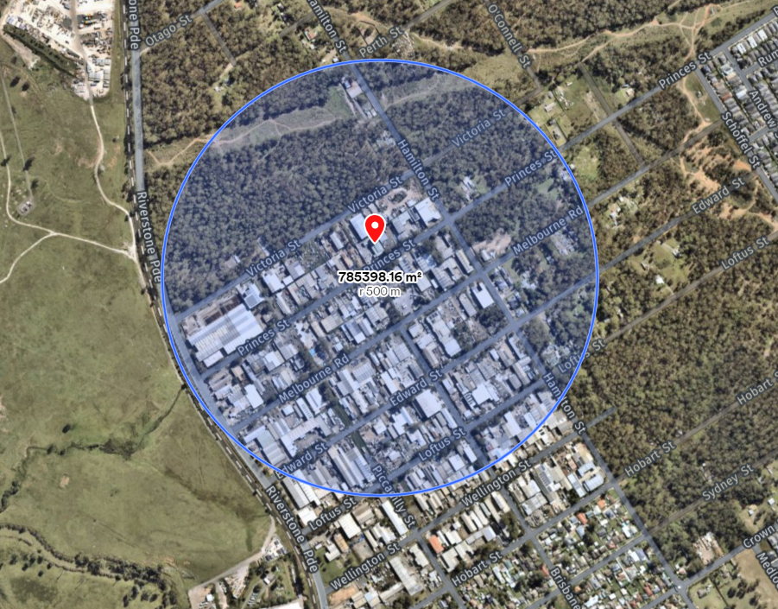

Map 2 – Site map
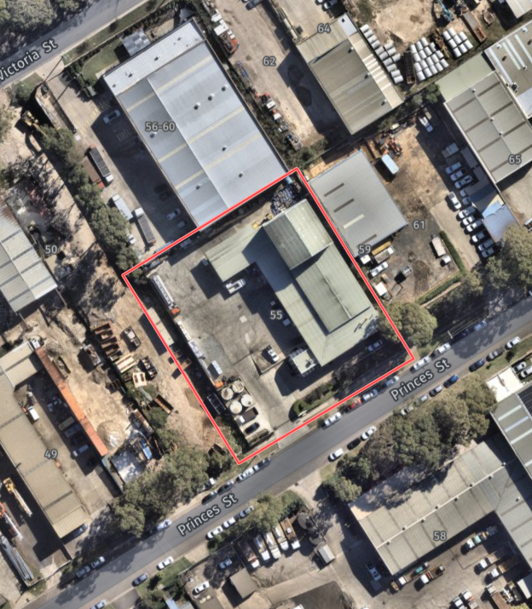
Map 3 – Stormwater Discharge Location Offsite

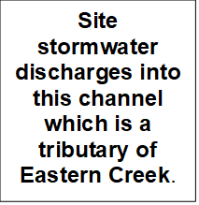
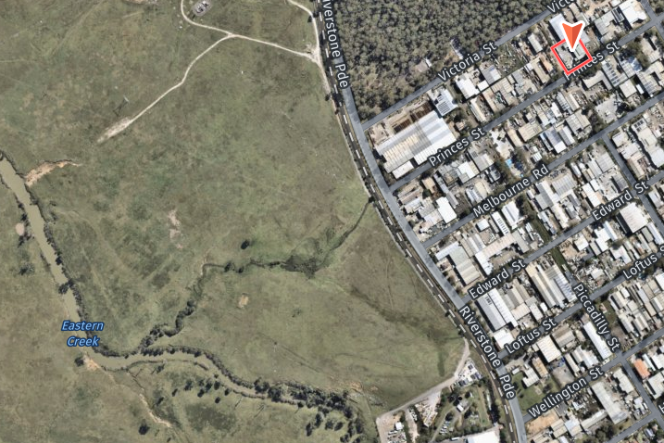
- Actions to be taken during or immediately after a pollution incident
The risk assessment in Section 5 of the PIRMP ‘Description of Likelihood of hazards’ outlines potential pollution incidents at the Premises. Additionally, the site maintains a site-specific Environmental Risk Register which details a range of information about the facility and its controls. Refer to Sections 1 to 5 of the Environmental Risk Register for more information.

Section 6 of the PIRMP ‘Pre-emptive Actions’ outlines the pre-emptive controls, how an identified risk to human health or the environment will be reduced and actions to be taken during or immediately following a pollution event to minimise its risk.

Actions to Minimise a Pollution Incident:
CWY operations shall make all attempts to prevent pollution events / to ensure environmental incidents do not occur, but in a situation where a pollution incident is imminent and it may potentially cause detrimental impacts to human health or the environment, onsite operations will contact the necessary stakeholders (employees, contractors, neighbours, Regulatory Authorities) to provide as much early warning as possible.

Further, CWY will abide by the requirements detailed in Section 147 and Section 153F of the POEO act.

Actions During a Pollution Incident:
In the event that a pollution incident requires the evacuation of the site, actions will be completed in accordance with the Site Emergency Management Plan Appendix 1. All staff are informed on the location of muster locations through site inductions, signage and ongoing training.
Actions Post a Pollution Incident:
A detailed incident investigation and report will be completed regarding the Pollution Incident to find the root cause of the incident and implement the corrective actions to prevent the incident occurring.

The incident will be reported in the Myosh incident management system. If CWY are notified of the pollution incident by the public, a complaint will also be registered in the Myosh reporting system.

Within a month following the incident, the PIRMP will be reviewed and tested. CWY will continue to liaise with the relevant Regulatory Authorities to reduce the likelihood of the pollution incident occurring.

The Incident will be discussed at the toolbox meeting forum with all staff and contractors regarding the incident investigation, key outcomes and follow up on the completing of the corrective actions.
- Coordinating with Persons & Regulators
Licensees must notify all of the appropriate Regulatory Authorities following a notifiable incident. These include:
- Environment Protection Authority (EPA);
- Ministry of Health;
- Comcare;
- Local Council; and
- Fire and Rescue NSW.

As outlined in Section 3 of the PIRMP ‘Pollution incident - Notification of relevant authorities’, notification of the incident is to be provided by the Operations Manager, Regional Manager and/or Tertiary contact.

All Communications are to be made to:
Operations Manager; and
Regional Manager.

- Staff Training
Annual PIRMP toolbox meetings will be completed with staff on the site. This training will be provided to ensure that all staff are aware of the content, processes and requirements of the plan and competently implement if necessary.

This PIRMP toolbox is in addition to Cleanaway’s other training modules and induction processes.

- Testing & Updating of the PIRMP
Plans must be tested routinely at least once every 12 months and within one month of any pollution incident occurring. The testing is to be carried out in such a manner as to ensure that the information included in the plan is accurate and up to date, and that each plan is capable of being implemented in a workable and effective manner. Testing may include:
- Desktop scenarios, or
- Physical Scenarios.
Testing records will be maintained electronically on the ‘MyOSH’ database (entered as Drill & Exercise > PIRMP Test).

Date PIRMP tested | PIRMP tested by | Type of test  (drill or desktop) | Learnings | Next scheduled test
8/09/2023 | Operations Team | Drill | N/A | September 2024
08/08/2024 | - Monica Burton  - Sam Holesegrove  - Richard Saliba  - Jacob MacAndrew  - Nana Amankwah  - Melinda Hale | Drill | Location of drainage system onsite and offsite and potential methods of blocking drains in the event of a spill. | August 2024
07/08/2025 | - Ramesh Gajurel  - Monica Burton  - Jacob Macandrew  - John Benson  - Nana Amankwah | Drill | Controlling the overflow | August 2026
29/07/2026 | - Ramesh Gajurel  - Jacob MacAndrew  - John Benson | Drill | Controlling the overflow | July 2027

