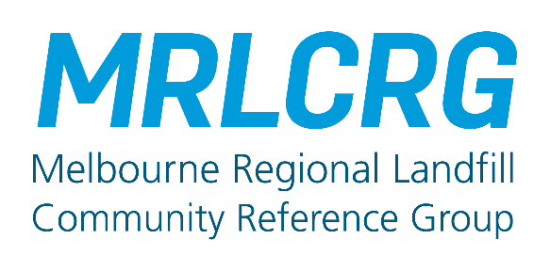
MRLCRG
Melbourne Regional Landfill Community Reference Group

Applicant details and contact information

Full name:
Address:
Telephone:
Email:
*This information is mandatory. Contact details will not be shared beyond the CRG Facilitator.

1. Please explain your interest in joining Melbourne Regional Landfill Community Reference Group:
Click or tap here to enter text.
2. How would your contribution to the group be reflective of broader community interests and
opinions?
Click or tap here to enter text.
3. How would you ensure information is openly shared with the community?
Click or tap here to enter text.
4. Are you a member of other committees or advisory groups? (If any)
Click or tap here to enter text.
5. All members of the MRLCRG are required to abide by the conditions set out in the Terms of
Reference and adhering to meeting behaviours and conduct, as collaboratively agreed to by the
group.
Do you acknowledge and accept these requirements (please tick):
YES ☐

6. Do you foresee any issues or potential for conflict of interest?
Click or tap here to enter text.
7. Is there anything further you would like to express or add to your application?
Click or tap here to enter text.

Please return completed form by post or by email to:
Susan McNair, MRLCRG Facilitator Currie, M2 West Podium,
525 Collins Street, Melbourne 3000
Susan@curriecommunications.com.au

